**Written Examination**

### Why is Java considered platform independent? :- The same java program can run on any operating system.

1. **What are JVM, JRE, and JDK?? :-** JVM(Java Virtual Machine) is a Java runtime engine that offers a runtime environment for Java code and applications.
2. **What is the difference between ArrayList and vector? :-** Array list is fast because it is non-synchronized and Vecto is slow because it is synchronized.

### How do equals() and == differ? :- equals() evaluates to the comparison of values in the object and == checks if both objects point to the same memory location.

### Explain public static void main(String args[]) in Java :- This is java main method, we can only change the name of String array argument.

### Why Java is not 100% Object-oriented? :- It supports primitive data type such as long, it, byte, and others that aren’t objects.

### What are wrapper classes in Java? :- A class whose object wraps or contains primitive data types.

### What are constructors in Java? :- Constructor is used to initialize objects.

### What is singleton class in Java and how can we make a class singleton? :- A class that can have only one object at a time. First of all we can declare the constructor of the singleton class with the private keyword, and a private static variable of the same class that is the only instance of the class after that declare a static factor method with the return type as an object of this singleton class.

1. **What is a package in Java? List down various advantages of packages. :-** A way to encapsulate a collection of classes, sub-packages and interfaces. **1.** Make it simple to find classes and interfaces by searching or locating them. **2.** Avoid naming conflicts. **3.** Put data encapsulation into practice. **4.** Provide restricted access: The protected and default access specifiers provide package-level access control.
2. **Why pointers are not used in Java? :-** They point to memory locations or are utilized for memory management, but when we use them directly, they lose their security.
3. **What are access modifiers in Java? :-** private, public, Default and protected
4. **What is an object in Java and how is it created? :-** It is a Member of a class, specify the class name, followed by the object name, and use the keyword new.
5. **What is the difference between a local variable and an instance variable? :-** Instance variable is a variable that is declared in a class but outside a method and Local variable is a variable declared within a method or a constructor.
6. **What is final keyword in Java? :-** The final keyword is useful when you want a variable to always store the same value
7. **Is a finally block executed when an exception is thrown from a try block that does**

**not have a catch block, and if so, when? :-** The finally block always executes when the try block exits.

1. **Draw an ER diagram according to the technical exercise provided :-** 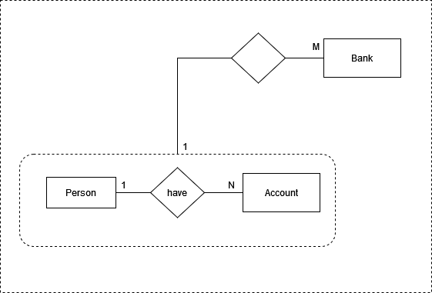
2. **Implement normalization and sample table design for above drawn ER diagram :-**

**I)Person**

**PID, Pname, AccID, BID**

**II)Account**

**AccID, type**

**III)Bank**

**BID, BName**